Arbor Parent Portal – FAQs

**How can parents sign up for the Parent Portal if they have a child at more than one school using Arbor?**

When a parent logs into the Parent Portal or the Arbor App they can see details about their children that attend one school using Arbor. If they have two children attending the same school, they can easily switch between students in the app or on the website.

But how does the Parent Portal work for parents with children at more than one school who use Arbor?

If a parent has children at more than one school their experience of logging into the Parent Portal and Arbor App will be a little different. If they use the same email address on their profile at both schools they will be asked which school they want to log into when they visit [login.arbor.sc](https://login.arbor.sc/) or go to log into the Arbor App.

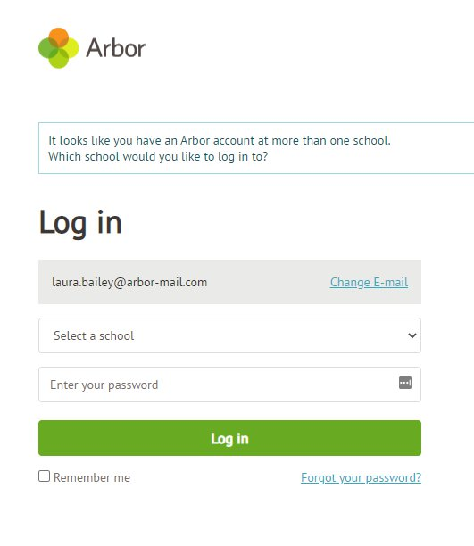

**Please note: The parent won't be able to switch between students on the Parent Portal/Arbor App if the students attend two different schools. They will need to log out of one account and into another to see the information for both students.**

# How long can a parent see a student after they have left the school?

Parents are able to view any students on the Parent Portal and Arbor App until the end of the academic year the student was last enrolled in.

* If they are linked to more than one student, at the end of the academic year they will lose access to the child who has left the school but will still be able to access their other child(ren).
* If all of their children have left the school, they won't be able to log in, and will see the below message.